**Hands on with sample bash scripting**

1: Creating a file(siva) through script

Commands

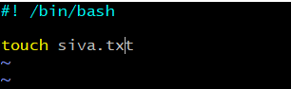

Result:

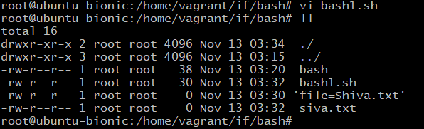

2: Creating and deleting the file through script

Commands:

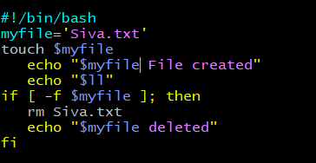

Output:

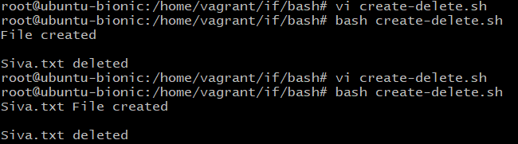

3: To install python through bash script

Commands:

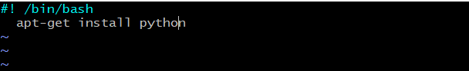

Output:

